Module: IN2033 – UG Stage 2 Team Project
Project: InfoPharma Ordering System (IPOS)
Team:
Project Manager: Furqan Khokhar
Deputy Project Manager: James Cahill
Minute-taker: Huzefa Farooq
Date: Wednesday 4 February 2026
Duration: 48 minutes
Location: WhatsApp (online)
Attendees:
- All team members
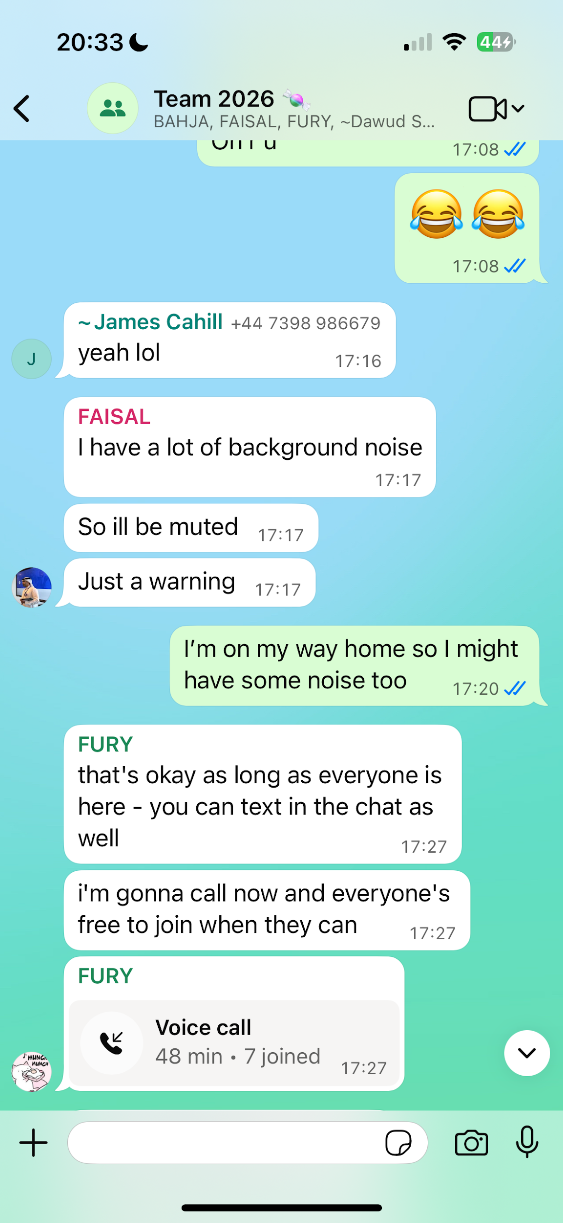

Agenda & Discussion

1. Project progress and initial deliverables
- The team agreed to begin work on the first project deliverable.
- Initial system design activities were prioritised, with a focus on producing UML diagrams.

2. Design approach
- The team discussed the use of use case diagrams versus user stories for capturing system requirements.
- It was agreed that UML design would commence while the most appropriate requirements approach is finalised.

3. Project planning and documentation
- A project binder was created to centralise project documentation.
- A Gantt chart was produced to outline the project timeline and key milestones.
- Tasks were assigned to team members; detailed task allocations were recorded in a separate shared Google document.

4. Meetings and communication
- The team discussed the schedule and format of future meetings, including continued use of online communication tools.
- A future meeting with the project consultant was discussed, with the aim of selecting a time when most, if not all, team members can attend the meeting with Konstantin.

Next Meeting
- Date: To be confirmed
- Time: To be confirmed
- Location: Online (TBC)

